Project Documentation
  - ISTE-330 Database Connectivity and Access

J.9 TDI Car Dealership

Document (filename):
Author(s): Ivan Karlo, Tomislav Tešija, Danis Harmandić, Jurica Jamić
Date (last change): 27.3.2026.
Version (last version): 1.1
Version | Description of Change | Author(s) | Date
1.0 | Document created | Ivan Karlo, Tomislav Tešija, Danis Harmandić, Jurica Jamić | 2026-03-26
1.1 | First three chapters filled | Ivan Karlo, Tomislav Tešija, Danis Harmandić, Jurica Jamić | 2026-03-27
1.2 | Fixed previous mistakes and chapters filled for milestone 3 | Ivan Karlo, Tomislav Tešija, Danis Harmandić, Jurica Jamić | 2026-04-06

  - Table of contents
1 Introduction 3
1.1 Overview 3
1.2 Purpose and Scope 3
1.3 Background 3
1.4 References 3
1.5 Document Overview 3
2 Problem Description and Solution Architecture 4
2.1 Problem Description 4
2.2 Technologies and Architectural Design 4
2.3 Database Layer and Database Connectivity Layer 4
2.4 Business Layer 4
2.5 Presentation Layer 5
2.6 Areas of particular concern 5
3 Requirements 6
3.1 Context 6
3.2 Functional Requirements 6
3.3 Other (Non-Functional) Requirements 6
4 User Documentation 7
4.1 Graphical User Interface Design 7
4.2 User Manual 7
5 Installation, Configuration and Acceptance Testing 8
5.1 Installation 8
5.2 Configuration 8
5.3 Acceptance Testing 8
6 Final Remarks and Conclusion 9

Introduction

Overview
This project is about developing a Car Dealership System, which will be a web-based application for managing and viewing cars for sale. The system will help customers browse available vehicles and see important details such as brand, model, year, price, and mileage. At the same time, it will help dealership staff manage the inventory by adding, updating, and removing car listings. The goal of the project is to make the dealership process more organized, easier to use, and more efficient for both customers and administrators.

Purpose and Scope
The purpose of this document is to describe the planned Car Dealership System and explain the main idea behind the project. It gives an overview of the problem, the planned solution and the main parts of the system. It is intended for car dealerships that want a simple way to manage their vehicles and customer purchase information. Document also focuses on the project goals, requirements, and system design, but it does not go into full implementation details yet.

Background
This document is created by our student team as part of the ISTE-330 course at RIT Croatia. The team consists of Jurica Jamić, Ivan Karlo, Danis Harmandić, and Tomislav Tešija. The goal of this project is to design and build a database-driven application that solves a real-world problem. We chose to develop a car dealership system because it is a practical example that allows us to apply concepts like database design, connectivity, and basic application structure.

References
During the development of this project, several official documentations and tools will be used as references. These include:
- Java Documentation (Oracle): https://docs.oracle.com/en/java/
- MySQL Documentation: https://dev.mysql.com/doc/
- MySQL Connector/J (JDBC Driver) Documentation: https://dev.mysql.com/doc/connector-j/en/

In addition to programming-related documentation, the following resources will also be used:
- Course materials and lecture slides from ISTE-330
- MySQL Workbench (database design and management tool)
- Visual Studio Code (development environments)
- Git and GitLab (version control and collaboration)
These references support the development, design and documentation of the system throughout the project.

Document Overview
This document is organized into several chapters that describe different parts of the project. The Introduction chapter gives a general overview of the project, its purpose, background, and references used during development.
The Problem Description and Solution Architecture chapter explains the main problem being solved and describes the planned system, including technologies, architecture, database design, and different layers of the application.
The Requirements chapter defines what the system should do by listing functional and non-functional requirements, as well as how the system fits into a broader context. The User Documentation chapter focuses on the user interface and explains how users will interact with the system, including basic usage instructions.
The Installation, Configuration and Acceptance Testing chapter describes how to set up the system, configure it, and test whether it works correctly.
Finally, the Conclusion chapter summarizes the project, reflects on the development process, and highlights possible improvements for the future.

Problem Description and Solution Architecture

Problem Description
Current methods of managing car dealership inventory often lead to data inconsistency. Small to medium-sized dealerships frequently rely on spreadsheets or outdated local software that does not allow for real-time updates or easy access to vehicle specifications like mileage, pricing, and model history. This results in administrative problems when adding or removing stock and a frustrating experience for customers who cannot easily browse available inventory.
Our solution is database-driven web application that streamlines these processes. Unlike basic spreadsheets, this system provides a structured environment where dealership staff can perform CRUD operations on inventory with immediate data persistence. For customers, it offers a clean, searchable interface to view up-to-date listings. By using a relational database, we ensure data integrity (e.g., preventing a car from being sold twice) and provide a scalable foundation that outperforms non-specialized digital tools.

Technologies and Architectural Design
We will use a layered architecture to ensure the system is modular, maintainable, and secure.
- Programming Language & Framework: Java was chosen for the backend due to its robust support for database connectivity and object-oriented structure, which is ideal for representing complex entities like vehicles and customers.
- Database Management: MySQL serves as our relational database. It is ideal for this project because it handles complex relationships between cars, customers, and sales with high integrity.
- Frontend: HTML, CSS, and JavaScript will be used to create a responsive, user-friendly interface.
- Rationale: This design separates the user interface from the database logic. If we decide to change the database in the future, the frontend remains unaffected, ensuring long-term flexibility.
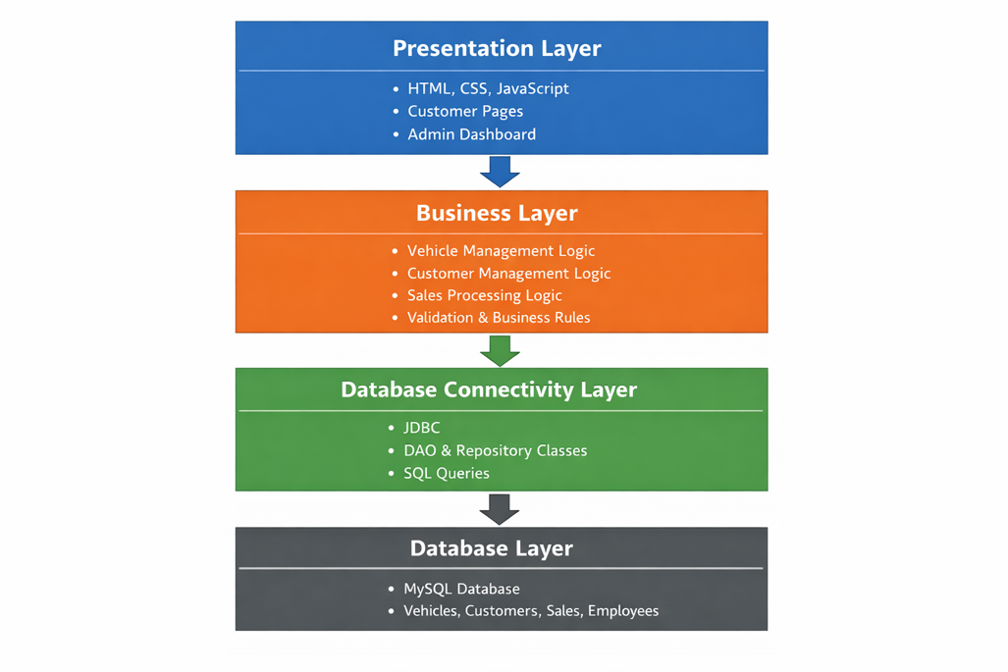
The following diagram presents the layered architecture of the proposed Car Dealership System. It shows the separation between the presentation layer, business layer, database connectivity layer, and database layer. This structure ensures that the web-based user interface does not communicate directly with the database, but instead passes all requests through the business and connectivity layers, which improves maintainability, modularity, and security.

Database Layer and Database Connectivity Layer
The system is built on a relational schema consisting of 15 interconnected tables. The architecture centers around the Vehicles entity, which acts as the core of the inventory. By separating data into specialized table - such as Manufacturers, Models, and Customers—the system enforces referential integrity. This ensures, for example, that a sales record cannot exist without a valid associated vehicle and customer, preventing "orphaned" data and maintaining a clean audit trail for dealership operations.
The following diagram represents the physical schema, illustrating how Primary Keys and Foreign Keys link the inventory, staff, and customer entities to facilitate complex queries and reporting.
To ensure consistency across the development team, the following dictionary defines the characteristics and constraints for the core database entities.

Table Name | Column Name | Data Type | Constraints | Description
Vehicles | vehicle_id | INT | PK, AUTO_INCREMENT, NOT NULL | Unique identifier for each car in stock.
Vehicles | vin | VARCHAR(17) | UNIQUE, NOT NULL | 17-character Vehicle Identification Number.
Vehicles | model_id | INT | FK -> Models(model_id), NOT NULL, ON DELETE RESTRICT, ON UPDATE CASCADE | Reference to the specific vehicle model.
Vehicles | price | DECIMAL(10,2) | NOT NULL | Listing price of the vehicle.
Vehicles | status | VARCHAR(20) | NOT NULL, DEFAULT 'Available' | Current vehicle status such as Available, Reserved, or Sold.
Customers | customer_id | INT | PK, AUTO_INCREMENT, NOT NULL | Unique identifier for each customer.
Customers | email | VARCHAR(100) | UNIQUE, NOT NULL | Customer email address used for contact.
Employees | emp_id | INT | PK, AUTO_INCREMENT, NOT NULL | Unique identifier for each employee.
Sales | sale_id | INT | PK, AUTO_INCREMENT, NOT NULL | Unique identifier for each sale transaction.
Sales | sale_date | DATE | NOT NULL | Date when the sale was recorded.
Sales | vehicle_id | INT | FK -> Vehicles(vehicle_id), NOT NULL, ON DELETE RESTRICT, ON UPDATE CASCADE | Vehicle included in the sale.
Sales | customer_id | INT | FK -> Customers(customer_id), NOT NULL, ON DELETE RESTRICT, ON UPDATE CASCADE | Customer associated with the sale.
Sales | emp_id | INT | FK -> Employees(emp_id), NOT NULL, ON DELETE RESTRICT, ON UPDATE CASCADE | Employee who recorded the sale.
MaintenanceHistory | maintenance_id | INT | PK, AUTO_INCREMENT, NOT NULL | Unique identifier for each maintenance entry.
MaintenanceHistory | vehicle_id | INT | FK -> Vehicles(vehicle_id), NOT NULL, ON DELETE CASCADE, ON UPDATE CASCADE | Vehicle that received maintenance service.
MaintenanceHistory | service_date | DATE | NOT NULL | Date when maintenance was performed.
MaintenanceHistory | description | VARCHAR(255) | NOT NULL | Description of service or repair performed.
Roles | role_id | INT | PK, AUTO_INCREMENT, NOT NULL | Unique identifier for each employee role.
Roles | role_name | VARCHAR(50) | UNIQUE, NOT NULL | Name of the role, such as Admin or Salesperson.
Permissions | permission_id | INT | PK, AUTO_INCREMENT, NOT NULL | Unique identifier for each permission.
Permissions | permission_name | VARCHAR(100) | UNIQUE, NOT NULL | Name of the allowed system action.
VehicleChangeLog | log_id | INT | PK, AUTO_INCREMENT, NOT NULL | Unique identifier for each log entry.
VehicleChangeLog | vehicle_id | INT | FK -> Vehicles(vehicle_id), NOT NULL, ON DELETE CASCADE, ON UPDATE CASCADE | Vehicle record that was modified.
VehicleChangeLog | emp_id | INT | FK -> Employees(emp_id), NOT NULL, ON DELETE RESTRICT, ON UPDATE CASCADE | Employee who made the change.
VehicleChangeLog | change_type | VARCHAR(50) | NOT NULL | Type of action performed, such as INSERT, UPDATE, or DELETE.
VehicleChangeLog | change_date | DATETIME | NOT NULL | Date and time when the change was made.
Manufacturers | manufacturer_id | INT | PK, AUTO_INCREMENT, NOT NULL | Unique identifier for each manufacturer.
Manufacturers | name | VARCHAR(100) | UNIQUE, NOT NULL | Name of the vehicle manufacturer.
Models | model_id | INT | PK, AUTO_INCREMENT, NOT NULL | Unique identifier for each vehicle model.
Models | manufacturer_id | INT | FK -> Manufacturers(manufacturer_id), NOT NULL, ON DELETE RESTRICT, ON UPDATE CASCADE | Manufacturer associated with the model.
Models | model_name | VARCHAR(100) | NOT NULL | Name of the model.
EmployeeRoles | emp_id | INT | FK -> Employees(emp_id), NOT NULL, ON DELETE CASCADE, ON UPDATE CASCADE | Employee assigned to a role.
EmployeeRoles | role_id | INT | FK -> Roles(role_id), NOT NULL, ON DELETE CASCADE, ON UPDATE CASCADE | Role assigned to an employee.
EmployeeRoles | assigned_date | DATE | NOT NULL | Date when the role was assigned.
RolePermissions | role_id | INT | FK -> Roles(role_id), NOT NULL, ON DELETE CASCADE, ON UPDATE CASCADE | Role linked to a permission.
RolePermissions | permission_id | INT | FK -> Permissions(permission_id), NOT NULL, ON DELETE CASCADE, ON UPDATE CASCADE | Permission linked to a role.
Reservations | reservation_id | INT | PK, AUTO_INCREMENT, NOT NULL | Unique identifier for each reservation.
Reservations | vehicle_id | INT | FK -> Vehicles(vehicle_id), NOT NULL, ON DELETE RESTRICT, ON UPDATE CASCADE | Vehicle that has been reserved.
Reservations | customer_id | INT | FK -> Customers(customer_id), NOT NULL, ON DELETE RESTRICT, ON UPDATE CASCADE | Customer who made the reservation.
Reservations | reservation_date | DATE | NOT NULL | Date when the reservation was created.
TestDrives | test_drive_id | INT | PK, AUTO_INCREMENT, NOT NULL | Unique identifier for each test drive booking.
TestDrives | vehicle_id | INT | FK -> Vehicles(vehicle_id), NOT NULL, ON DELETE RESTRICT, ON UPDATE CASCADE | Vehicle chosen for the test drive.
TestDrives | customer_id | INT | FK -> Customers(customer_id), NOT NULL, ON DELETE RESTRICT, ON UPDATE CASCADE | Customer who booked the test drive.
TestDrives | scheduled_date | DATE | NOT NULL | Scheduled date of the test drive.
VehicleImages | image_id | INT | PK, AUTO_INCREMENT, NOT NULL | Unique identifier for each vehicle image.
VehicleImages | vehicle_id | INT | FK -> Vehicles(vehicle_id), NOT NULL, ON DELETE CASCADE, ON UPDATE CASCADE | Vehicle associated with the image.
VehicleImages | image_url | VARCHAR(255) | NOT NULL | Path or URL of the stored vehicle image.

Business Layer
The Business Layer serves as the central logic engine of the Car Dealership System, acting as the intermediary between the user interface and the data storage. Its primary purpose is to enforce the rules - ensuring that all data processing follows specific dealership policies before any information is committed to the database or displayed to a user.
The Business Layer will be constructed using Java classes that represent the core logic of the dealership. For example, when a sale is processed, this layer is responsible for calculating final totals, validating that the chosen vehicle is actually "Available" in the inventory, and ensuring the customer's information meets required formats. By isolating this logic into its own layer, we ensure that the system is modular; if the dealership changes its sales tax or discount policies, we only need to update the Business Layer without altering the Database or Presentation layers.
The Business Layer is organized through Java classes and service components that handle specific dealership operations such as vehicle management, customer management, reservation handling, and sales processing. Each of these components is responsible for applying business rules before data is passed further to the Database Connectivity Layer. For example, the vehicle-related logic checks whether VIN values are unique, the sales-related logic verifies that a vehicle is still available before a sale is recorded, and customer-related logic ensures that required customer information is complete before it can be connected to a reservation or sale. In this way, the Business Layer keeps the application logic centralized and prevents invalid operations from reaching the database.
This layer facilitates a communication between the top and bottom tiers of the application:
- It receives raw input from the HTML/JavaScript front-end. The Business Layer validates this input for errors or security risks before processing the request.
- Once the data is validated, the Business Layer sends a structured request to the Java/JDBC connectivity layer to perform the necessary operations. It never interacts with the MySQL database directly, ensuring that the database remains protected by a layer of logic.
After the Database Connectivity Layer completes the requested operation, the result is returned to the Business Layer, which prepares the appropriate response for the Presentation Layer. This allows the user interface to display success messages, validation warnings, or error messages based on the processed request. By controlling both validation and response handling, the Business Layer ensures that communication between the user interface and the data layer remains consistent and secure.

Presentation Layer
The Presentation Layer will be implemented as a web interface using HTML, CSS, and JavaScript. HTML will define the structure of the pages, CSS will be used for styling and layout, and JavaScript will support interactivity such as searching, filtering, and validating form input. The interface is designed to be easy to use and organized in a logical way.
For customers, the user interface includes pages for browsing available vehicles, searching and filtering listings, and viewing detailed information about a selected car. For dealership staff, the interface includes an administrative dashboard where employees can add, update, and remove vehicles, as well as manage customer and sales records.
The Presentation Layer communicates directly with the users and indirectly with the rest of the system through the Business Layer. When a user performs an action in the interface, such as searching for a vehicle, submitting a form, or recording a sale, the request is sent to the backend logic for validation and processing. After the request is handled, the result is returned to the user interface, where the system displays the updated data, confirmation messages, or validation errors. This separation ensures that the Presentation Layer remains focused on user interaction and display, while the Business Layer handles application rules and decision-making.
The following wireframes present the planned structure of the graphical user interface for both customers and dealership staff. They show the main pages, page layout, and the most important user actions in the system. This approach matches the document requirement that the presentation layer can be shown through prototypes or wireframes at this stage of development.
The presented wireframes illustrate the main navigation structure and interface elements of the system. The customer-facing pages focus on browsing and viewing vehicle information, while the employee-facing dashboard focuses on data entry, record management, and administrative tasks. Together, these screens show how different user roles interact with the system through a clear and structured graphical interface.
Customer Inventory Page Wireframe:
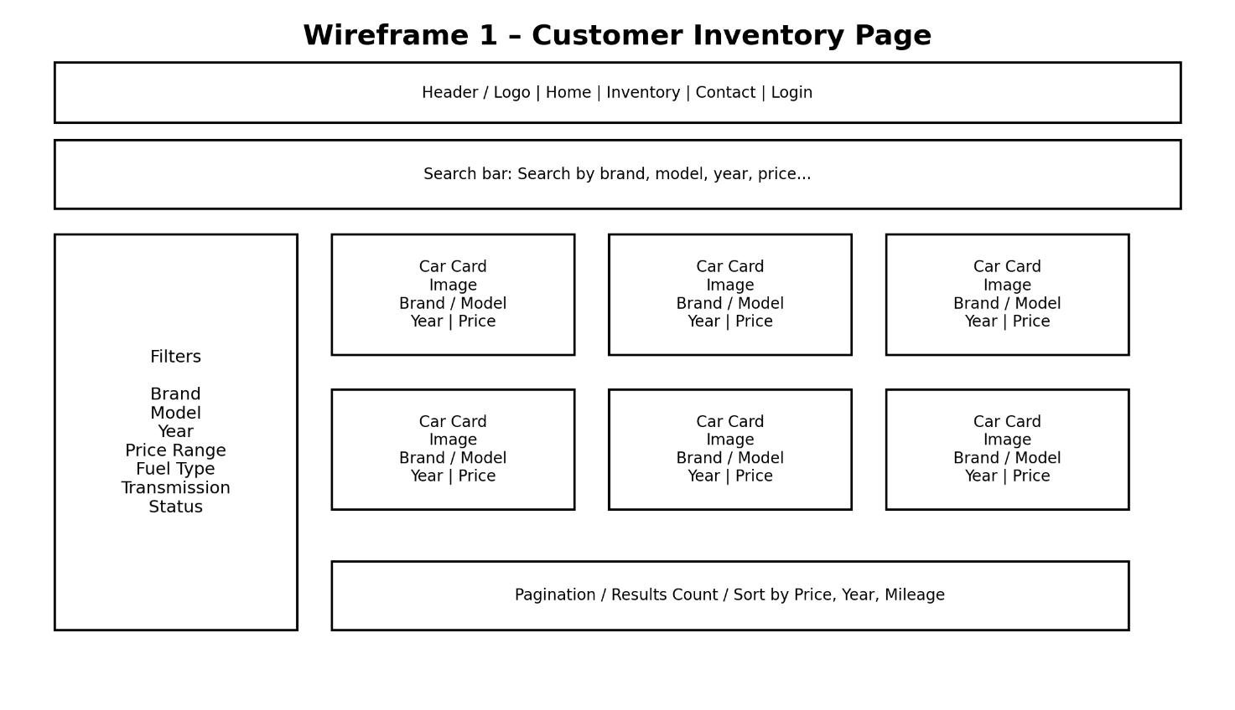
This wireframe shows the main page for customers. It includes a search bar, filter options, and a grid of vehicle cards. The purpose of this page is to help users quickly browse available cars and narrow results based on their preferences.
Vehicle Details Page Wireframe
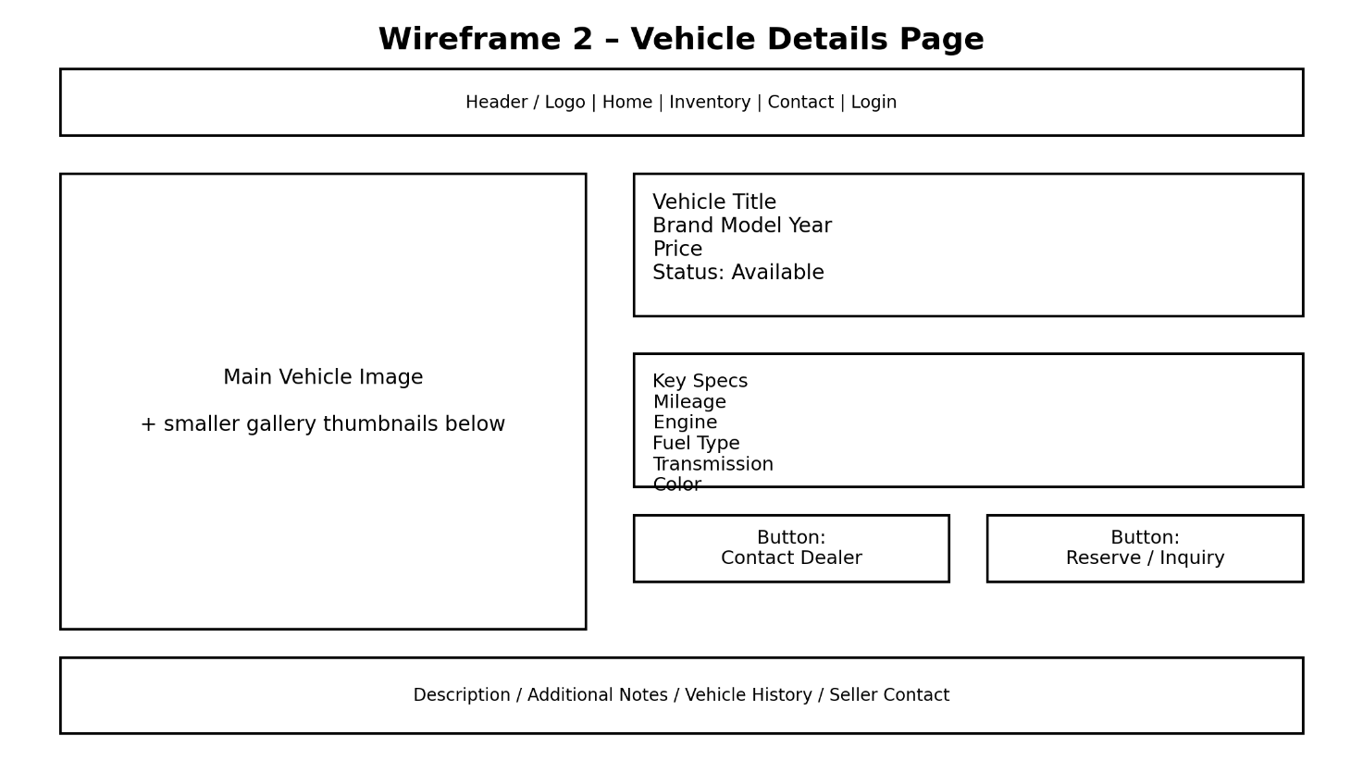
This wireframe shows the layout of a single vehicle details page. It contains the main vehicle image, price, status, specifications, and action buttons such as contacting the dealer or sending an inquiry. This page gives users a more detailed view of a selected car.
Admin Dashboard Wireframe
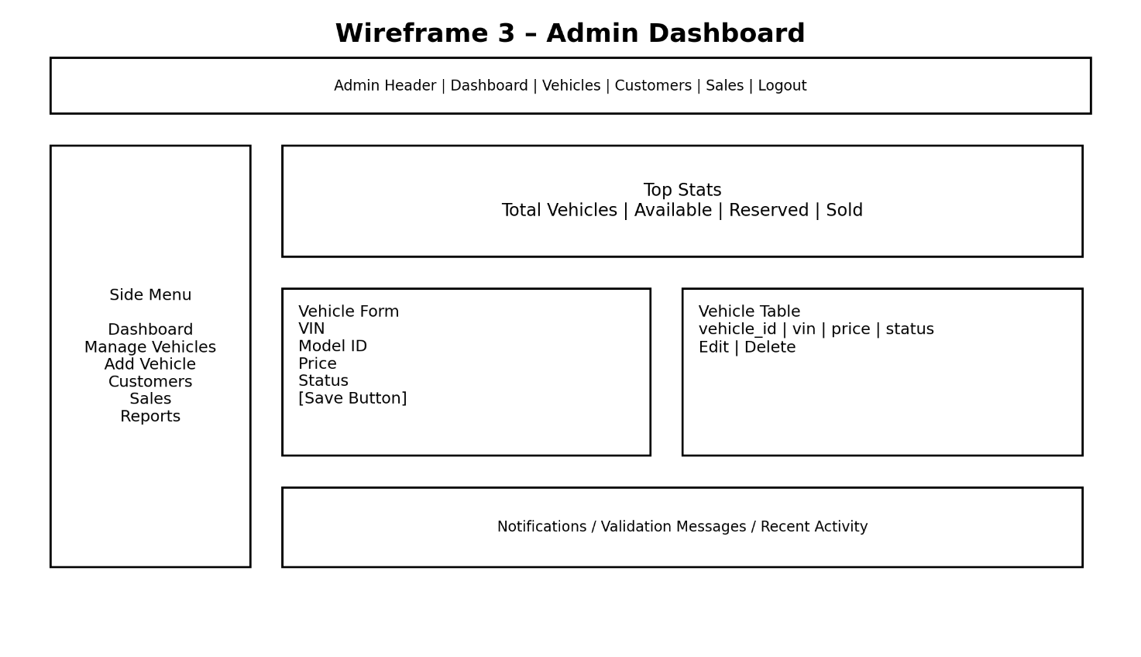
This wireframe presents the employee or administrator interface. It includes navigation options, overview statistics, a vehicle input form, and a data table for managing records. The purpose of this page is to support dealership staff in performing administrative tasks efficiently.

Areas of particular concern
There are several important concerns in this project. One of the main risks is team coordination. Since this is a group project, delays from one team member can affect the progress of the whole system. To reduce this risk, the team should divide tasks clearly, communicate regularly, and use GitLab to track work.
Another concern is the integration of the technologies used in the project. The system combines a web interface, Java business logic, JDBC, and a MySQL database. If these parts are not connected correctly, errors may happen. This risk can be reduced by testing each layer separately before combining them.
Database design is also an important area of concern. The tables and relationships must be correct so that the system can store and retrieve data properly. Using primary keys, foreign keys, and constraints will help keep the data consistent.
Another area of concern is validation and access control. Since the system includes both public customer pages and restricted employee functions, it is important to ensure that only authorized users can perform administrative actions and that invalid input does not affect stored data. This risk can be reduced by applying input validation in the Business Layer and restricting access to the administrative interface.

Requirements

Context
The Car Dealership System is designed as a web-based application that would be used in a typical small or medium car dealership. The system connects three main parts: the web interface that users see, the business logic written in Java, and the MySQL database where all data is stored.
The application does not use any external payment systems. Instead, it only simulates the sales process. This means that when a car is sold, the employee records the sale in the system, but the actual payment happens outside of the application. Customers use the system through a web browser. They can browse available cars, search and filter listings, and view detailed information about each vehicle. Customers do not need to log in or create an account, since their role is only to view available data.
Dealership employees use a separate admin interface. Through this interface, they can add new vehicles, update existing ones, remove cars from the system, manage customer data, and record sales. All these actions go through the Business Layer, which checks if the data is valid before sending it to the database. The system uses standard technologies such as a web browser for the frontend, Java for backend logic, and MySQL for storing data. Each part of the system is separated into layers, which makes it easier to manage and update in the future.
Overall, the system works as a simple, independent solution for managing dealership inventory and basic sales records, without relying on any external services.

Functional Requirements

The functional requirements of the Car Dealership System include both standard inventory and customer management operations, as well as more advanced business rules. In addition to basic CRUD-related actions, the system also performs automatic validation, sales-related calculations, permission checks, and status updates in order to support more realistic dealership processes.

ID | Functional Requirement | Description | "used by"
FR1 | View Vehicle Listings | The system allows customers to view all available vehicles in the inventory. | Customer
FR2 | Search Vehicles | The system allows customers to search vehicles based on keywords such as brand or model. | Customer
FR3 | Filter Vehicles | The system allows customers to filter vehicles by price, year, mileage, or status. | Customer
FR4 | View Vehicle Details | The system shows detailed information about a selected vehicle, including price, specifications, and status. | Customer
FR5 | Add Vehicle | The system allows employees to add a new vehicle to the inventory. | Employee
FR6 | Update Vehicle | The system allows employees to update information about an existing vehicle. | Employee
FR7 | Remove Vehicle | The system allows employees to remove a vehicle from the inventory. | Employee
FR8 | Manage Vehicle Status | The system allows employees to change vehicle status, such as Available, Reserved, or Sold. | Employee
FR9 | Register Customer | The system allows employees to add a new customer to the database. | Employee
FR10 | Update Customer Data | The system allows employees to update customer information. | Employee
FR11 | Record Sale | The system allows employees to record a completed sale in the system. | Employee
FR12 | Validate Vehicle Availability | The system checks whether a vehicle is available before allowing a sale to be recorded. | System
FR13 | Prevent Duplicate VIN | The system ensures that each vehicle has a unique VIN number. | System
FR14 | View Sales Records | The system allows employees to view all recorded sales. | Employee
FR15 | Input Validation | The system validates all user input, such as required fields and correct data formats. | System
FR16 | Calculate Final Sale Price | The system automatically calculates the final sale price based on the listed vehicle price, applicable taxes, and any approved discounts. | System
FR17 | Verify Customer Record Before Sale | The system prevents a vehicle from being marked as Sold if the selected customer record is incomplete or missing required information. | System
FR18 | Automatically Update Vehicle Status After Sale | Once a sale is successfully recorded, the system automatically updates the vehicle status to Sold. | System
FR19 | Log Vehicle Listing Changes | The system records important changes made to vehicle listings, including which employee performed the action and when the change was made. | System
FR20 | Validate Employee Permissions | The system checks employee roles and permissions before allowing access to restricted administrative actions. | System
FR21 | Prevent Duplicate Active Reservations | The system prevents more than one active reservation from being created for the same vehicle at the same time. | System
FR22 | Track Vehicle Maintenance History | The system stores and displays maintenance and service history for vehicles when such records exist. | Employee

Other (Non-Functional) Requirements
The system should run on a standard computer with a modern web browser (such as Chrome or Edge). On the backend side, it requires Java (JDK installed), MySQL database, and MySQL Connector/J for database connectivity. Development and testing can be done using tools like Visual Studio Code and MySQL Workbench.
The application should be available at all times when the server is running. Since this is a simple dealership system, it is expected to be used by a small number of users at the same time (for example, a few employees and multiple customers browsing). The system should handle multiple requests without crashing or slowing down significantly.
Performance should be acceptable for basic operations. Actions such as loading vehicle listings, searching, and saving data should be completed within a few seconds. The system does not need to handle large-scale traffic, but it should still be responsive and stable.
Error handling should be implemented to prevent the system from crashing. If an error occurs (for example, invalid input or database issue), the system should show a clear message to the user and log the error for debugging purposes.
Security requirements are basic but important. The system should validate all user inputs to prevent incorrect or harmful data from being stored. Access to the admin interface should be restricted to employees only. Sensitive data, such as customer information, should be handled carefully and not exposed unnecessarily.
The system should follow standard coding and naming conventions to ensure readability and maintainability. Since this is a team project, consistent structure and use of Git for version control are important.
Overall, the system is designed to be simple, stable, and easy to maintain, without requiring complex infrastructure or high-end hardware.

User Documentation

Graphical User Interface Design
The graphical user interface of the Car Dealership System is designed as a web-based interface intended for two main user groups: customers and dealership employees. The goal of the interface is to provide a clear, modern, and visually appealing experience while keeping navigation simple, intuitive, and efficient. At this stage of the project, the design is represented through wireframes that illustrate the main screens, layout structure, and expected interaction flow.
The customer-facing side of the system is designed to emphasize vehicle presentation and easy browsing. The main inventory page displays available vehicles in a clean and organized layout, allowing users to quickly scan listings and identify vehicles of interest. Search and filtering options are placed in a visible and accessible part of the page so that customers can narrow results based on criteria such as manufacturer, model, price, year, mileage, and status. The design aims to highlight important vehicle information without overwhelming the user with unnecessary details.
When a customer selects a vehicle, the system opens a dedicated vehicle details page. This page is designed to present the selected car in a more focused and informative way, with emphasis on images, price, status, and technical specifications. Information is organized so that the most important details are immediately visible, while secondary details remain easy to access. The layout is intended to create a professional and structured browsing experience that supports informed decision-making.
The employee-facing side of the system is designed as an administrative dashboard that supports the operational needs of the dealership. Through this interface, employees can add new vehicles, update existing listings, remove vehicles, manage customer records, record sales, and access additional dealership data such as reservations, maintenance history, and change logs. The dashboard is planned to use a structured combination of navigation menus, forms, and tabular views in order to keep management tasks efficient and easy to follow.
From a user experience perspective, the interface is designed around clarity, consistency, and ease of use. Navigation should remain consistent across pages, actions should be clearly labeled, and important features should be easy to locate. Forms should indicate required fields clearly and provide immediate feedback when invalid or incomplete data is entered. The interface also separates customer-facing functionality from employee-only functionality, which improves both usability and system security.
The technologies used for the graphical user interface are HTML, CSS, and JavaScript. HTML is used to define the structure and content of the pages, CSS is used for styling, spacing, and layout, and JavaScript is used to implement interactivity such as searching, filtering, validation, and dynamic updates. The backend of the system is implemented in Java, which handles the application logic and communicates with the relational database. This structure allows the frontend to remain focused on presentation and interaction, while the backend manages processing, validation, and database access.

User Manual

At this stage of the project, the user manual provides an initial overview of how the main features of the Car Dealership System are used. The system supports two main user roles: customers and dealership employees. Each role uses a different part of the application and has access to different functions. In later milestones, this section will be expanded with screenshots and more detailed step-by-step instructions.
4.2.1 Customer Usage
Customers use the public part of the web application to browse available vehicles and view vehicle details. When a customer opens the system, the main inventory page is displayed. This page shows all available vehicles together with key information such as manufacturer, model, year, mileage, price, and current status.
To find a specific vehicle more easily, the customer can use the search bar to enter keywords such as the manufacturer or model name. The customer can also apply filters such as price, year, mileage, and availability status in order to narrow the list of displayed vehicles.
When a vehicle is selected, the system opens the vehicle details page. This page presents additional information about the selected car, including technical specifications, price, images, and current availability. This allows the customer to review a vehicle in more detail before deciding whether it is of interest.
4.2.2 Employee Usage
Dealership employees use the administrative dashboard to manage dealership records and perform operational tasks. Through this interface, employees can add, update, and remove vehicle listings, manage customer records, and record completed sales.
To add a new vehicle, the employee opens the vehicle entry form and enters the required information, such as VIN, manufacturer, model, price, mileage, and status. After the form is submitted successfully, the vehicle is stored in the database and becomes part of the system inventory.
To update a vehicle, the employee selects an existing listing and changes the necessary data, such as the price, mileage, or status. If a vehicle should no longer be shown in the system, the employee can remove the listing from the inventory.
Employees can also add and update customer records. These records are used when dealership activities such as reservations or sales need to be connected to a specific customer.
To record a sale, the employee selects the vehicle and the customer involved in the transaction and submits the sale information. Before the sale is saved, the system checks whether the selected vehicle is available and whether the linked customer data is valid and complete.
4.2.3 Validation and System Responses
During normal system use, the application performs validation in order to maintain accurate and consistent data. Required fields must be completed before forms can be submitted, VIN values must remain unique, and invalid or incomplete entries are rejected.
When an employee attempts to record a sale, the system checks whether the vehicle is still available and whether the related customer information is complete. If validation fails, the system displays an error or warning message and prevents the action from being completed. If validation succeeds, the system saves the data and updates the affected records accordingly, such as changing the vehicle status after a completed sale.

Installation, Configuration and Acceptance Testing

Installation
This chapter explains how the Car Dealership System will be set up, configured, and tested. Since the project is still being developed, this part of the documentation is not fully finished yet, but it gives an overview of what will be needed for the system to run properly and how its functionality will later be checked. As the implementation progresses, this chapter will be expanded with more specific technical instructions, configuration details, and testing steps. In the final version of the project, this chapter will include the software and tools required to run the application, the steps for setting up the database and backend connection, and the main tests that will be used to confirm that the system works as expected. The goal of this chapter is to make it clear how the application can be prepared for use and how its main features can be verified.
This section will describe the basic steps required to install and run the system. It will include the main software requirements, such as Java, MySQL, MySQL Connector/J, and the tools used during development. In later milestones, this part will be expanded with a more detailed step-by-step installation process.

Configuration
This section will describe the main configuration settings needed for the application to work correctly. This includes connecting the Java backend to the database, defining database connection parameters, and setting any default values required by the system. More detailed configuration instructions will be added later when the implementation is more complete.

Acceptance Testing
This section will describe how the system will be tested to make sure it meets the project requirements. The testing will focus on the main functionalities of the application, such as viewing vehicles, searching and filtering listings, managing customer and vehicle data, and recording sales. In later milestones, this section will include specific test cases, expected results, and a clearer explanation of how the system will be evaluated.

Final Remarks and Conclusion
[Usually, this chapter should be started later, and at least partially filled with deliverable and milestone #3 or #4, and should be finished with deliverable and milestone #5. You should summarize the experiences, both in terms of the produced results and work on the project. List all project deliverables, as well as positive (and negative) experiences and concerns. Comment on missing functionalities and possibilities for improvement and extensions. Estimate project effort (person-hours) and how it was distributed in time and per team roles. This chapter can also include a work log summary for all team members (for each day who did what).]

At this stage of the project, the Car Dealership System has been defined through its main architecture, database structure, requirements, and user interface design. The documentation now includes the problem description, layered solution design, database model, functional and non-functional requirements, and an initial user-oriented description of the system.
So far, the project has established a solid foundation for further development. Positive aspects include the clear layered structure of the application and the detailed database design. At the same time, some challenges remain, especially in keeping the database, business rules, and user interface design consistent, as well as coordinating team work efficiently.
Some parts of the project are still incomplete and will be expanded in later milestones, including installation and configuration details, acceptance testing, and a more detailed user manual with screenshots. Overall, the project has progressed well through the current milestone and provides a strong basis for the remaining implementation and documentation work.

